|  |  |  |
| --- | --- | --- |
| Product Catalogue | RF radio frequency coaxial connector |  |
| Connector type | Board end |  |
| Radio frequency series | SMA |  |
| Interface type | 内孔 |  |
| Number of ports | 1 |  |
| Impedance | 50Ω |  |
| Frequency - Maximum Value | 3GHz |  |
| Style | 弯头 |  |
| Interface diameter | 5.35mm |  |
| Interface length/height | - |  |
| Operating temperature range | -55℃~+125℃ |  |

External thread nut half-thread SMA - KWE bend angle (90 degrees), fully copper plated with gold

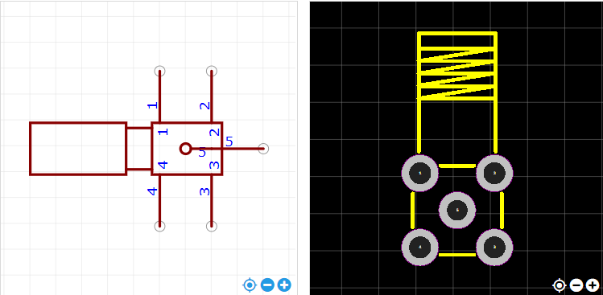

<https://item.szlcsc.com/985455.html>